Power Bi Module End Assignment
Bike Stations Analysis Using Power BI
Project Overview and Objective
    - This project analyzes a bike-sharing station dataset to evaluate station availability, operational status, and geographic distribution across regions, helping stakeholders understand system performance and coverage.
    - To monitor open vs closed station status and overall network health, To analyze bike availability rate for operational efficiency
    - To identify high- and low-coverage regions using geographic mapping, To support data-driven decisions for station expansion and maintenance planning.
Problem Statement
  - Lack of clear visibility into real-time bike availability across stations affects user satisfaction.
  - High number of stations makes it difficult to track operational status (open vs closed) efficiently.
  - Uneven geographical distribution of active stations may lead to service gaps in certain regions.
  - Decision-makers lack data-backed insights to prioritize station maintenance and expansion.
  - Without performance analysis, it is hard to optimize bike utilization and reduce downtime.
Tools and Technologies
- Power BI: Data cleaning, transformation, Data modelling, DAX calculations, visualization, and interactive dashboard creation.
Date Pre-Processing (Power Query)
Task Performed:
- Data Cleaning & Transformation: Removed duplicates, handled missing values, standardized formats, and created calculated fields.
- Filtering & Sorting: Organized data to focus on relevant records.
Data Modelling and DAX(Power BI)
- Calculated Columns & DAX Measures: Implemented DAX formulas for key metrics, such as Total Stations, Active Stations, Total Bike Stands, Total Available Bikes, Total Available Bike Stands, Bike Utilization %, bike availability Rate %
Transform to Power query

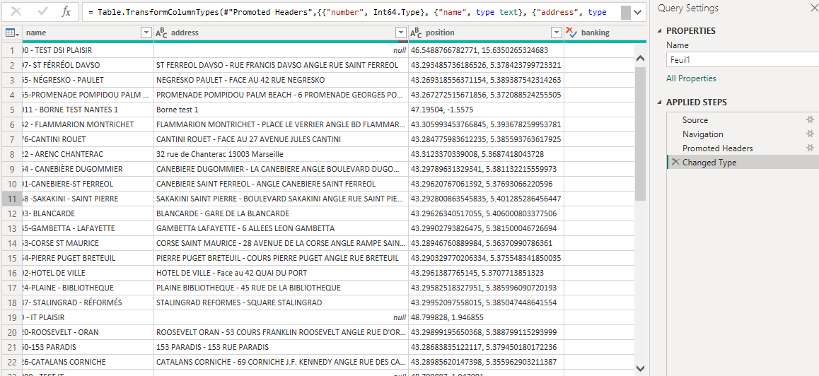
Removed Duplicates
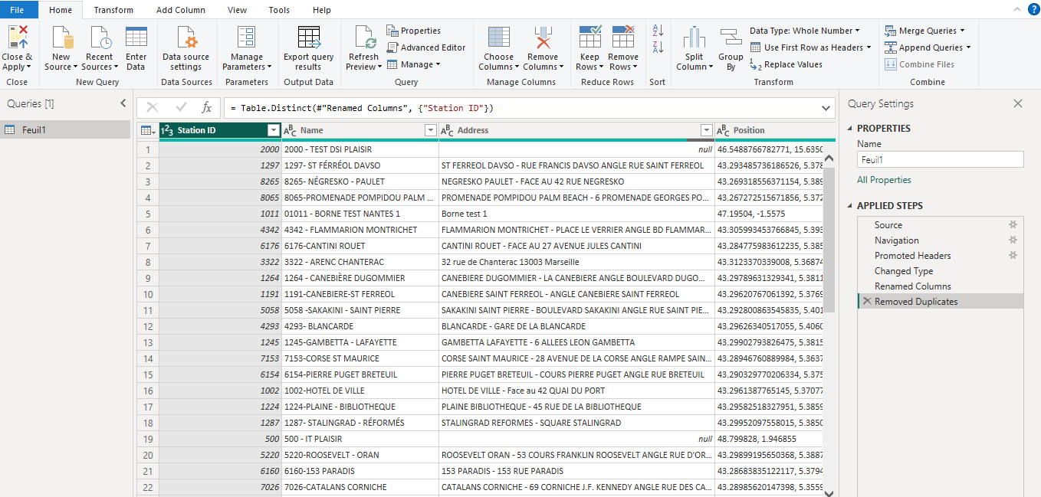
Data Modelling
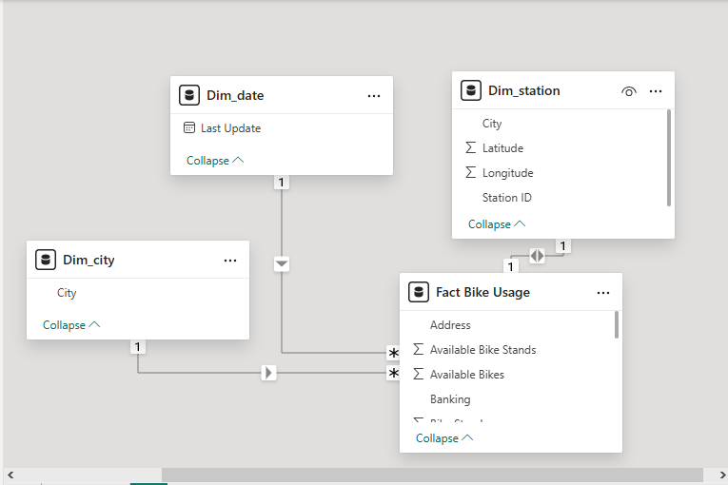
Calculated Dax Measure
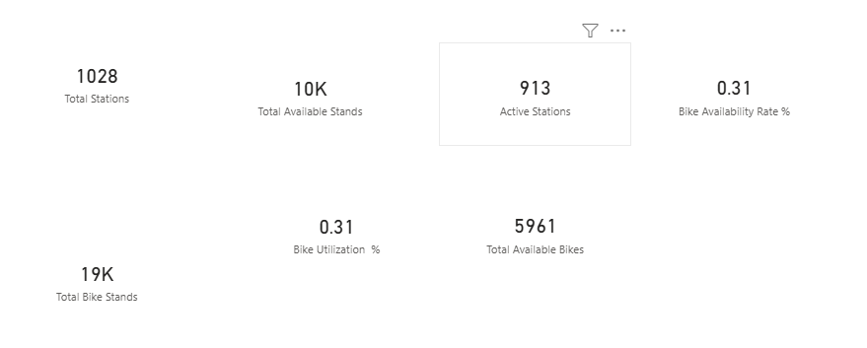
Analaysis and Visualizations(Power BI)
Dashboard Features:

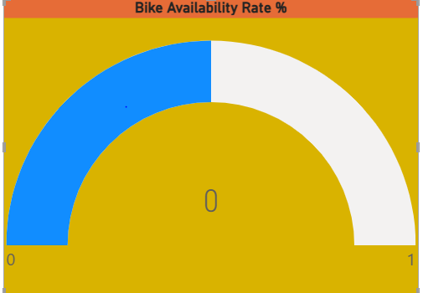
Bike Availability Rate %
    - The bike availability rate is critically low, indicating that users are currently unable to find bikes across most stations.
    - This near-zero availability highlights a severe imbalance between bike demand and supply in the network.
    - Operational intervention is urgently required, such as bike redistribution or fleet expansion, to restore service reliability.
    - Sustained low availability at this level can negatively impact user trust and overall system usage.
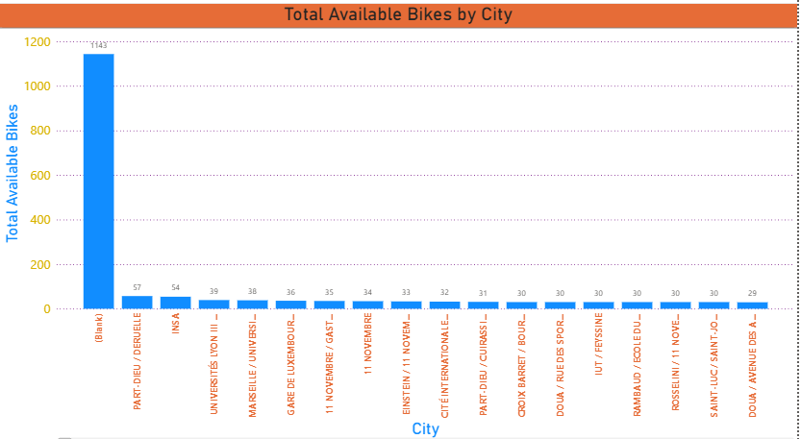
Total Available Bikes by City
    - Paris–Île-de-France dominates bike availability, holding an exceptionally higher number of available bikes compared to all other cities.
    - All remaining cities show very low and closely clustered bike availability, indicating a strong imbalance in network distribution.
    - Cities such as Nantes and Lyon have moderate availability but still fall far behind the leading city, highlighting centralized supply.
    - The sharp drop after the top city suggests that bike resources are heavily concentrated rather than evenly allocated across locations.
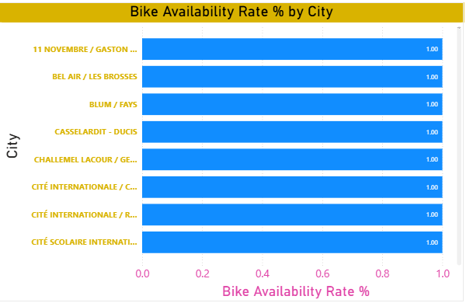
Bike Availability Rate % by City
    - All listed cities show a bike availability rate of 100%, indicating that every bike stand currently has bikes available.
    - The uniform availability rate across cities suggests no immediate bike shortages in these locations.
    - Such consistently high availability may point to low current demand or recent bike redistribution efforts.
    - While availability is optimal, sustained 100% rates could also indicate under-utilization of bikes in these cities.
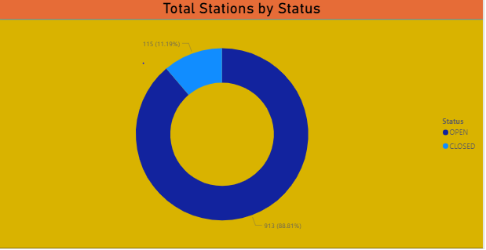
Total Stations by Status
    - The vast majority of stations are operational, with approximately 89% marked as OPEN, indicating strong network availability.
    - Only about 11% of stations are CLOSED, suggesting limited service disruption across the system.
    - The high proportion of active stations reflects effective maintenance and operational management.
    - The small share of closed stations highlights targeted opportunities for restoration rather than widespread network issues.
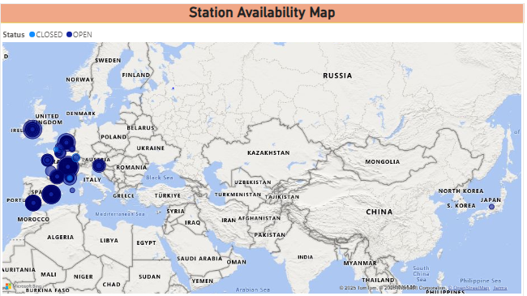
Station Availabililty Map
- Stations are heavily concentrated in Western Europe, indicating this region as the primary operational hub.
- Open stations clearly dominate the map, with closed stations appearing sparse and geographically scattered.
- There is minimal station presence in Asia, Africa, and the Middle East, showing limited geographic coverage beyond Europe.
- High clustering of stations in countries like France, Germany, and nearby regions suggests dense urban or high-demand deployment.
Consolidated Report / Dashboard

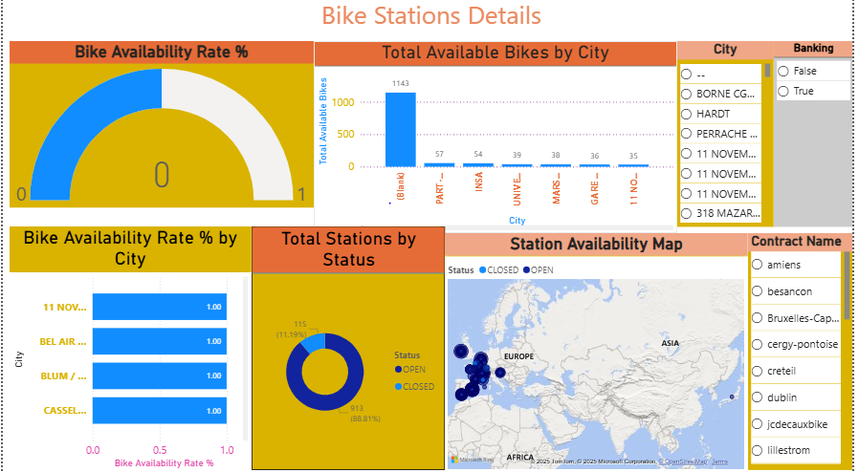
Insights & Conclusion
Descriptive Analytics:
    - Most bike stations in the network are operational, with OPEN stations significantly outnumbering CLOSED ones.
    - Bike availability rates across cities indicate that bikes are generally accessible at most stations.
    - Station locations are highly concentrated in European regions, especially in major urban areas.
    - Only a small fraction of stations are inactive, reflecting stable operational performance of the bike-sharing system.
Diagnostic Analytics:
    - High bike availability rates in several cities indicate lower demand or recent bike redistribution rather than increased supply.
    - The small percentage of closed stations suggests that operational downtime is likely due to localized maintenance issues rather than system-wide failures.
    - The heavy concentration of stations in certain regions explains the imbalance in bike availability across cities.
    - Under-utilization at stations with consistently high availability points to mismatched station placement or timing of demand.
Predictive Analytics:
    - Stations with consistently low bike availability are likely to face shortages during peak hours in the near future.
    - Cities showing declining availability trends may require additional bikes or station expansion to meet upcoming demand.
    - Inactive or low-utilization stations are likely to remain underperforming unless relocated or demand patterns change.
    - Seasonal and daily usage patterns can predict periods of high congestion, enabling proactive bike rebalancing.
Prescriptive Analytics:
    - Increase bike supply at stations with low availability rates to prevent service disruptions during peak demand.
    - Redistribute bikes from low-utilization stations to high-demand areas to optimize overall system efficiency.
    - Schedule maintenance or temporary closures for consistently inactive stations to reduce operational costs
    - Use demand forecasts to plan dynamic rebalancing routes and staffing for improved station performance.
Conclusion
- This analysis provides clear visibility into bike station availability, utilization, and operational status, helping identify high-demand areas and underperforming stations. The insights support data-driven decisions for bike redistribution, capacity planning, and service optimization, ultimately improving system efficiency and user satisfaction.

